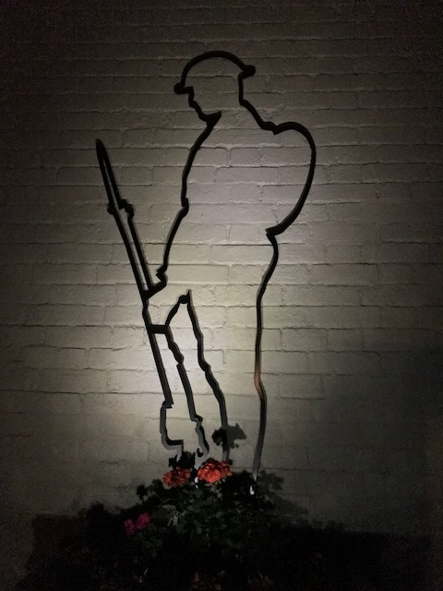

**The 75th Anniversary**

**For**

**The Ending of World War Two**

**And VJ Day in 1945**



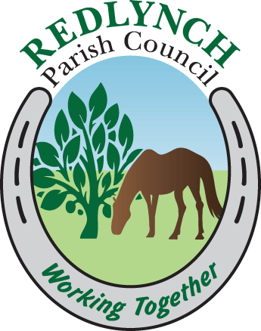

**Saturday 15 August 2020**

**Gary Robert**

**on**

**Cornet**

**Bowers Hill Memorial**

**2020 Thanksgiving**

Arrival of the RBL Standard and the Minister

Introduction and welcome

Reverend Len Lunn RBL

**Hymn to be spoken**

Immortal, invisible, God only wise,

In light inaccessible hide from our eyes,

Most blessed, most glorious, the ancient of days,

Almighty, victorious,

Thy great name we praise.

To all life **Thou** givest, to both great and small;

In all life Thou livest, the true life of all;

**We** blossom and flourish as leaves on the tree,

And wither and perish, but nought, changeth Thee.

Great Father of glory, pure Father of light,

Thine Angels adore Thee, all veiling their sight;

All laud we would render: O help us to see,

Tis only the splendour of light hideth Thee.

**Commemorative Prayers**

Reverend Len Lunn RBL

**Wreath Laying**

The Royal British Legion

The Parish Council

The Exhortation

The Last Post

Kohima Epitaph

Reveille

**Hymn to be spoken**

Now thank we all our God,

With hearts and hands and voices,

Who wondrous things have done,

In whom his world rejoices;

Who from our mother’s arms,

Hath blest us on our way

With countless gifts of love,

And still is ours today.